1 Equipment Familiarization

This experiment introduces some of the equipment to be used in the implementation and testing of your ECE 3714 digital circuit designs. This equipment includes:
 MFJ 5002 Analog/Digital Test Box - To facilitate the interconnection of logic circuits with on-board power, circuit inputs and display outputs.
- Tektronix TDS 210 Oscilloscope - To allow accurate voltage and current measurements versus time.
- Digital Multimeter – used for measuring voltage values.
- Logic Probe – Used for quick sensing logic levels and the presence of pulses.

This lab assumes that you have purchased a prototyping breadboard for use with the MFJ 5002 Analog/Digital Test box.
You will need to fill out the lab DATA SHEET located at the end of this lab assignment during the performance of the lab. There is NO PRELAB for this assignment.

I. MFJ Logic Breadboard
………………………………………………………………………………………………………
A description of the MFJ 5002 Analog/Digital test box is provided in at the end of this document. Please read over this material before proceeding.

A. Read the material describing the test box (at end of this lab).
B. Plug the testbox in and turn the power on.
C. Verify that all LEDs work properly by connecting each to the +5V supply and noting that each LED comes on (use the wires from your prototyping kit).
D. Connect each LED to the GND pin to verify that all LEDs stay off when connected to ground.
E. Check the operation of all data switches by connecting each to a data indicator and noting which switch position is required to turn the LED on or off.
F. Verify the 5-pin commonality provided on the breadboard by connecting the +5V supply to one pin of the set and connecting one of the common pins to a data indicator. Repeat the connection to the LED from all of the other common pins in the set.
G. Verify the long row commonality provided on the breadboard in the same way as in part F for several pins along the row.
II. Digital Oscilloscope
The Tektronix Digital Oscilloscope (TDS 210) is very useful for displaying waveforms, and measuring voltages and time characteristics of waveforms.
This walkthrough is aimed to get you through displaying a waveform with the oscilloscope and measuring basic quantities of the waveform like voltage and frequency.
Refer to the picture below when performing the following exercises.

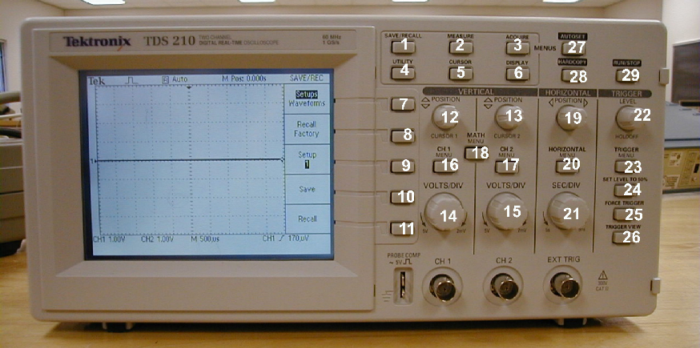

Displaying the waveform

1. Hook both the Channel 1 and Channel 2 probes to the clock output of the MFJ-5002 breadboard (you can get scope probes from the back of the room). Use the DIGITAL clock output (in lower left hand portion of the test block – slider switch with three positions). Read the material in Appendix B if you do not know what a clock signal represents.

2. Set the clock output of the breadboard to 1Mhz.

3. Connect the ground clips of the two oscilloscope probes to the COM output of the breadboard. The ground clips of the oscilloscope probe are the alligator clips connected to the probes.

4. Power up the oscilloscope and breadboard if they are not powered up yet.

5. Depending on the current oscilloscope settings, you may or may not see two clear waveforms on the oscilloscope screen.

6. Press the AUTOSET button (button #27) on the oscilloscope. The AUTOSET button will automatically adjust the display settings of the oscilloscope to give you a readable waveform. After a few seconds, you should be able to see two square waveforms on the oscilloscope screen. If you see only one waveform, or none at all, press the CH1 Menu or CH2 Menu buttons (buttons #16 and #17) a couple of times until both waveforms show up, then press the AUTOSET button again.

Pressing the Channel1 Menu and Channel2 Menu buttons will show or hide the corresponding waveforms.

7. Turn the Channel 1 VOLTS/DIV knob a few times. This knob changes the scale factor for viewing the channel 1 waveform. As you turn the knob, notice how the waveform is scaled taller or shorter accordingly. Knob #15 does the same for the channel 2 waveform.

8. Turn the SEC/DIV knob (knob #21). This changes the time-base for the waveforms. As the time-base is reduced, the waveforms will be 'compressed', and vice versa. The next few steps will show this in more detail.

9. On the breadboard, switch from the 1MHz clock to the 1kHz clock. You will see that the oscilloscope display has changed.

10. Turn the sec/div knob counterclockwise until you can see the waveform repeat itself a few times.

11. Press AUTOSET. As you can see, the AUTOSET button again sets the time-base and volts/division settings to display a readable waveform.

Measuring Voltages, Time Period and Frequency

Using cursors

12. Press the CURSOR button (button #5). The cursor menu will display on the oscilloscope screen.

13. Set the measurement type to 'voltage'. Do this by pressing button #7 until 'voltage' shows in the first menu slot.

14. Change the cursor source to Channel 1 by pressing button #8 until CH1 appears in the second menu slot. This ensures that any measurement displays are based on the channel 1 waveform.

15. Use knob #12 and knob #13 to set the position of the two cursor lines. Set cursor 1 and cursor 2 at the low and high voltage levels of the channel 1 waveform respectively.

16. Now, observe that the Cursor1 menu slot displays '-2.5V' while the Cursor2 menu slot displays '2.5V'. (your numbers may differ a bit). Also note that the Delta slot displays '5V'. The Cursor1 and Cursor2 slots display the position of the cursors, while the Delta slot displays the voltage difference between cursor 1 and cursor 2.

17. Now we will measure the frequency of the waveform. Set the cursor type to 'time' by pressing button #7 until 'time' shows up in slot 1. Note that the cursors have changed to vertical lines.

18. Place cursor 1 at the first rising edge of waveform 1, and place cursor 2 at the second rising edge of waveform 1.

19. Note that the Delta slot now shows the time period and frequency of the waveform. Expectedly, the time period is 1ms and the frequency is 1kHz (approximately) Change the digital clock switch on the MFJ box to 1 Mhz and repeat the frequency/period measurement. Afterwards, change the digital clock switch back to 1 Khz. (don’t forget to use the Autoset button after changing clock frequencies).

Using the 'Measure' Function

20. Press the MEASURE button (button #2).

21. Press button #7 until 'source' is highlighted in slot 1.

22. Press button #8 until 'CH1' shows up in the corresponding slot. Repeat with button #9.

23. Press button #10 until 'CH2' shows up in the corresponding slot. Repeat with button #11.

24. Now we can measure two quantities of waveform 1 and two quantities of waveform 2 simultaneously.

25. Press button #7 once. Note that in the first slot, 'type' is highlighted. This enables you to choose the type of quantity (e.g. voltage, frequency etc) to be measured.

26. Press button #8 until 'pk-pk' shows in the second slot. The slot now shows the peak-to-peak voltage of waveform 1.

27. press button #9 until 'freq' shows in the third slot. The slot now shows the frequency of waveform 1. Verify that period = 1/frequency and vice-versa.

28. The same can be done for the waveform 2. Press buttons #10 and #11 to display the peak-to-peak voltage and frequency of waveform 2.

By now you should be able to display two waveforms simultaneously on the oscilloscope, and take voltage and frequency measurements of the waveforms.

Triggering

29. Press the TRIGGER menu button (button #23). The trigger menu is now displayed on screen.

30 Press button #9 (source) until 'CH1' show up on the corresponding slot. This sets channel 1 as the trigger source.

31. Now, turn the TRIGGER knob until the trigger level (arrow at right side) is BELOW the channel 1 waveform. You notice that both the waveforms are 'floating' now.

- Move the trigger level to between the low and high voltage levels of the channel 1 waveform. You will see that the waveform is once again stable.
- Use button #8 to choose between rising and falling edge triggering. Note how the waveforms shift. If rising edge is chosen, the FIRST edge that is displayed is a rising edge (low to high transistion). If falling edge is chosen, the FIRST edge that is displayed is a falling edge (high to low transistion).

This exercise shows you the importance of triggering. To acquire a waveform, the trigger level must be set to a voltage level within the waveform's voltage range.

III. Digital Multimeter
A digital multimeter is used for measuring voltage, current, and resistance with the numeric value displayed in a digital readout.

- Get one RED and one BLACK lead from the back of the room (will have a banana jack on one end, and a pointed probe on the other end).
- Locate the multimeter at your station. Find an input labeled V/Ω (volt/ohms, RED), plug the RED lead into that input. Find an input labeled GND or Common (black), and plug the black lead into that input.
- Find the push button labeled AC/DC. Make sure that the button is set for DC (DC voltage).
- Find the push button labeled V (Volts), and push it in. This will set your multimeter to measure voltage.
- Locate the scale pushbuttons – these will change the maximum voltage values that your multimeter will be able to display. They will be labeled 200 mv (200 millivolts), 2V, 20V. Set the scale to 20 V.
- Measure the DC voltage level of the +5 V supply pin on the test box.
- Measure the voltage level of each switch input in both the up and down position.

IV. Logic Probe

Get a logic probe off of the rack from the back of the room (will look like a fat pencily with two wires that have red/black alligator clips for power/gnd, and a sharp, pointed end).
A. Connect the Red clip to +5 and the Black clip to COM (ground) on the test box.
- Set the logic family switch to TTL. Make sure the MEM/Pulse switch is set to PULSE. Touch the probe to a switch input on the test box and exercise the switch; note how the LED changes value when the switch is exercised.
- Note the probe indicators when the breadboard digital clock output is probed for frequencies of 1 Hz, 1 Khz, 1 Mhz.
D. Probe the PULSE output of the test box (pushbutton next to digital clock switch) and note the logic probe indicator lights when the PULSE pushbutton is depressed.
E. Change the MEM/PULSE switch to MEM and again probe the PULSE pushbutton output as in D. What is different?

LAB DATA PAGE
TA CHECKOFF SIGNATURE: ______________________________(must be legible!)

Section I. MFJ Logic Breadboard
(C) +5V → LEDs (ON/OFF) _______________
(D) GND → LEDs (ON/OFF) _______________
(F) 5-pin commonality(observations)

(G) 25-pin commonality(observations)

Section II. Digital Oscilloscope

16. Cursor 1 voltage:__________ Cursor 2 voltage: ____________ Delta:_________
19. 1Khz clock. Measured Period: _________ Measured Frequency: __________
1Mhz clock. Measured Period: _________ Measured Frequency: __________
26. Peak-to-Peak: ______________
27. Frequency: ______________
28. Peak-to-Peak: ______________ Frequency: _____________

Section III. Digital Multimeter
(B) POWER SUPPLY voltage output measured by digital meter

Power Supply | +5V | GND
Digital meter (measurements)

(D) DATA SWITCHES’ voltage output measured by digital meter

Data Switch | 1 | 2 | 3 | 4 | 5 | 6 | 7 | 8
“1” (voltage)
“0”(voltage)

Section IV. Logic Probe
(B) Data Switches
Data Switch | “1” | “0”
Logic Probe observations
(D) Clock

Clock Frequency | 1Hz | 1kHz | 100kHz
Logic Probe
Observations
(E) Pushbutton observations with Mem/Pulse switch:

Appendix A: Use of Breadboards and the MFJ Digital/Analog Test Box
This appendix will help in using the MFJ-5002 Digital/Analog Test box as well as the IEEE breadboard kit purchased by the student.

There are two prototyping components that will be used to build and test circuits in this lab:
- A portable breadboard (center of figure B.1, shown attached to the MFG Digital/Analog Test box).
- The MFG Digital/Analog Test box (figure B.2)

Section 1: Breadboard

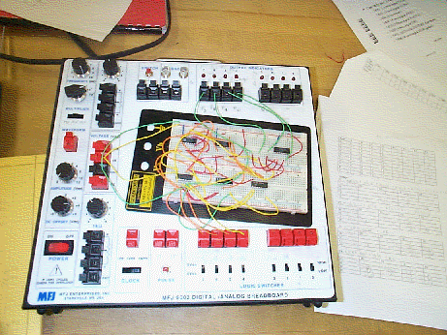
Figure B.1: A Breadboard connected to the MFG Test Box

A breadboard (purchased by the student from IEEE) is used for holding logic chips and wires that connect them together in order to realize a desired circuit. There are two types of common connections on the breadboard:

- 5-pin connections (busses)which run vertically (as shown in fig. B.1a) on the board
- 50-pin connections (busses) which run horizontally (as shown in fig. B.1a) on the board.

What is meant by common connections is that a row or column of common pins will have the same voltage as each other (or same logic state). This common connection will allow multiple connections to be made at the same pin on a logic chip. When placing a logic chip on the board, place it over the gap between the two sets of 5-pin connection (if it is done properly, it will fit right). To make a connection between two pins, or the D/A breadboard, take a wire and insert it in one of the common pinholes to the other desired pin. Figure B1.a shows a close up view of the breadboard indicating the connectivity of the 5 pin and 50 pin busses. Figure B1.b shows a 14 pin integrated circuit plugged into the breadboard (note how the integrated circuit straddles the white area between the 5 pin busses). Figure B1.c shows an offboard wire plugged into one of the 50 pin horizontal bus, then a short wire connecting the 50 pin bus to the 5 pin bus corresponding to pin #14. Figure B1.c also shows a short wire connecting pins 3 and 5 of the integrated circuit.

Figure B.1a: Close up view of a portion of a breadboard
5 pin holes connected vertically (see arrows)
Two row busses are connected horizontally (see arrows)

Fig B.1b: 14 pin Integrated Circuit plugged into Breadboard
Pin #1
Dot shows pin #1
Pin #7
Pin #14
Pin #8

Fig B.1c: Wire Connections, off board wire connected to pin #14, Pin #3 connected to Pin #5.
Arrows show connectivity
off board wire,
probably power
Pin #3
Pin #5
wire
wire

Section 2: MFG Digital/Analog Test Box

The MFG Digital/Analog Test box is used to provide power (+5V, GND), clock signals, switch inputs and LED outputs for a circuit mounted on a breadboard. External wires are used to connect the power supplies, switch inputs, etc on the MFG test box to your breadboard (you can see these wires in Figure B.1). When connecting a pin on your breadboard to the digital/analog (D/A) Test box (figure B.2), use a wire that has been inserted into one of the clamps on the D/A test box to the corresponding pinhole on your breadboard. To insert a wire in a clamp on the D/A test box, push down the lever opening the clamp, insert the wire, and then release the lever (thus closing the clamp).

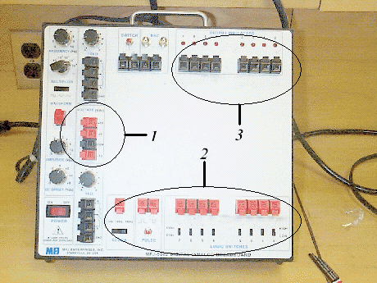
Figure B.2: Overhead view of MFG Digital/Analog Test box (Refer to numbers in Figure B.2 to get more information about that part of the breadboard.)

Number 1: Voltage and Ground Pins

When a integrated logic chip has a pin for Vcc (or Vdd), connect the +5 red clamp (shown in figure B.3) to that pin. When a GND, ground, or Vss pin is required, use the black COM clamp underneath the +5 clamp.

+5V

Gnd (COM)

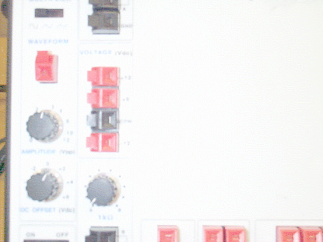
Figure B.3: Supply Voltage and Ground pins

Number 2: Logic Switches and Clocks

Another function of the D/A test box is to provide clock and the logic inputs as seen in Figure B.4. There are three frequencies for the clock input : 1Hz, 1kHz, and 1MHz. These can be selected by using the selection switch. VERY IMPORTANT!!: Use this clock instead of the one on the upper left of the D/A test box; the upper left clock is meant for analog applications. The eight logic switches are used as inputs to your circuit. When the switch is in the up position, a logic HIGH (or a 1) is asserted, and when the switch is down, a logic LOW (or a 0) is asserted. The clock and the logic switches are hooked up to the breadboard using external wires just like the Vdd/GND connections.

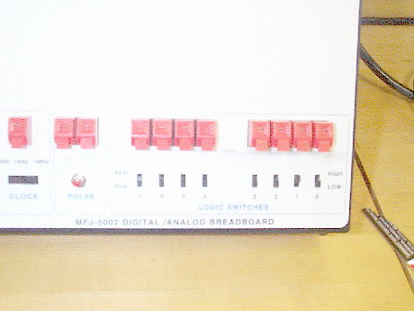

Figure B.4: Clocks and Logic Switches

Number 3: Output Indicators

The output indicators are LED's (Light Emitting Diodes) that allow you to check the condition of the outputs of a circuit. If an output is LOW, the LED's will be off; if the output is HIGH, the LED will turn on. Connect these using external wires in the same way as the VDD/GND supplies and clock inputs.

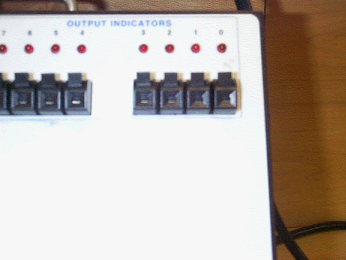
Figure B.5: LED Output Indicators

Appendix B: Clock Signal Definition
A clock signal is a repeating waveform that alternates between logic ‘1’ and logic ‘0’. The figure below gives the principle elements of a clock signal.

time
voltage
f = 1/τ
P_{w}
rising edge
falling edge
τ - period (in seconds)
P_{w} - pulse width (in seconds)
f - frequency pulse width (in Hertz)
duty cycle - ratio of pulse width to period (in %)
duty cycle = P_{w} /τ

The MFJ 5002 board provides digital clocks at three frequencies: 1 Mhz, 1 Khz, and 1 Hz. A 1 Mhz clock has a clock period (time between two successive rising edges or two successive falling edges) of 1 microsecond (1000 nanoseconds).

Appendix C: Digital Scope Reference Manual (Refer to #numbers on Picture)

Button/Knob # | Title | Function
1 | Save/Recall | Brings up save/recall menu
2 | Measure | Brings up measure menu
3 | Acquire | Brings up acquire menu
4 | Utility | Brings up utility menu
5 | Cursor | Brings up cursor menu
6 | Display | Brings up display menu
7 | - | Selects first menu option
8 | - | Selects second menu option
9 | - | Selects third menu option
10 | - | Selects fourth menu option
11 | - | Selects fifth menu option
12 | Vertical Position 1 | Moves channel 1 waveform up or down on screen
13 | Vertical Position 2 | Moves channel 2 waveform up or down on screen
14 | Volts/Div 1 | Selects voltage scale factor for channel 1
15 | Volts/Div 2 | Selects voltage scale factor for channel 2
16 | CH1 Menu | Brings up channel 1 menu.
17 | CH2 Menu | Brings up channel 2 menu
18 | Math Menu | Brings up math menu
19 | Horizontal Position | Adjusts the horizontal position of all channels
20 | Horizontal Menu | Brings up horizontal menu
21 | Sec/Div | Selects the horizontal time/div (scale factor) for the main time-base and the window zone. (refer horizontal menu help for explanation of window zone)
22 | Trigger Level | Adjusts signal level required to cause an acquisition.
23 | Trigger Menu | Brings up trigger menu
24 | Set Level to 50% | Sets trigger level to 50% of signal level.
25 | Force Trigger | Starts an acquisition regardless of an adequate trigger signal.
26 | Trigger View | Displays the selected trigger settings and the trigger waveform (button needs to be held down rather than pushed once).
27 | Autoset | Automatically adjusts the vertical position, volts/division and time base to give usable display of waveform.
28 | Hardcopy | This function is not supported by our oscilloscopes.
29 | Run/Stop | Starts and stops waveform acquisition.

Menu Descriptions

Use buttons 7 to 11 to toggle/select menu options. Each button toggles/selects the corresponding menu item directly to its left (refer diagram).

1. Save/Recall menu:

Setups / waveforms: Toggle between saving and recalling setups or waveforms.

Setups:
- Recall factory: Recall factory settings
- Setup: Choose slot to save setup in (slots available are #1 to #5)
- Save: Save settings
- Recall: Recall settings

Waveforms:
- Source: choose source of waveform to save
- Reference: choose the reference location to store or recall a waveform.
- Save: Save waveform to chosen reference location.

2. Measure Menu

Source / Type: Toggle between selecting source or type of measurement

Remaining 4 menu items are configurable for different sources and types. For example slot 2 can be configured to display frequency of channel 1 waveform, slot 3 can be configured to display V_{pk-pk} of channel 2 waveform etc. Use menu buttons (buttons #8 to # 11) to toggle/choose source and types.

3. Acquire Menu
- Sample: display a sample of the waveform
- Peak Detect: Use to detect glitches and reduce possibility of aliasing.
- Average: Display the waveform average taken over a number of iterations.
- Averages: Select number of iterations to average over, if ‘Average’ is chosen.

4. Utility Menu
- System status: view horizontal, vertical and trigger settings
- Self-calibration: oscilloscope does a self-calibration to ensure accuracy.
- View error log
- Change language: Select language for menu items to be displayed in.

5. Cursor Menu
- Type: Selects what the cursor is meant to measure (i.e. voltage or time)
- Source: selects source waveform for cursor measurements to be based on.
- Delta: displays the difference between the two cursors. If voltage is selected as the type, this slot displays the voltage difference. If time is selected, this slot displays the time difference.
- Cursor1: displays cursor1 location
- Cursor2: displays cursor2 location

* In the cursor menu, the vertical position knobs change the position of the cursors, not the waveforms.

6. Display Menu
- Type: selects between displaying waveforms as dots or vectors
- Persist:
- Format: Selects either waveform vs. time format or X-Y format.
- Contrast increase, contrast decrease: Adjusts screen contrast.

16: Channel 1 menu
- Coupling: Selects between AC, DC or ground. AC coupling does not display any DC offset component the waveform may have. DC coupling displays waveform along with DC offset component. Ground displays a constant ground waveform (used for adjusting vertical position).
- BW limit: Limits the bandwidth to reduce display noise.
- Volts/Div: Selects between course or fine adjusting of voltage/division knob. If this item is set to ‘fine’, then adjusting the volts/div knob will change the voltage sensitivity over a fine range of values.
- Probe: selects multiplier factor for probe. NOTE: For our oscilloscopes, in order to get actual value of measurements, use ‘10X’ for probe, not ‘1X’.

17. Channel 2 Menu

Same as channel 1 menu, except this menu selects the options for the channel 2 waveform.

18. Math Menu
- Ch1 – Ch2: Displays the waveform of the Channel 1 input minus the Channel 2 input.
- Ch2 – Ch1: Displays the waveform of the Channel 2 input minus the Channel 1 input.
- Ch1 + Ch2: Displays the waveform of the Channel 1 input plus the Channel 2 input.
- Ch1 inverted: displays the inverted waveform of Channel 1.
- Ch2 inverted: displays the inverted waveform or Channel 2.

20. Horizontal Menu
- Window zone: When this item is selected, user can use the horizontal sec/div knob to select range to zoom in, and use the horizontal position knob to select position of ‘window’ or range to zoom in to.
- Window: Zoom into selected range.

23: Trigger menu

Edge/Video: Toggle between using and edge trigger and video trigger

Edge: (Rising or falling edge of input signal is used for the trigger)
- Slope: Chooses between rising edge or falling edge trigger
- Source: Selects input source for the trigger signal.
- Mode: Selects type of triggering
Auto: Let the acquisition free-run in the absence of a valid trigger
Normal: Acquire only when valid trigger is present
Single: Capture only a single acquisition
- Coupling: Selects the components of the trigger signal applied to the trigger circuitry.
AC coupling: No DC offset
DC coupling: Include DC offset, if any.
Noise reject: Reject noise signals (signals with low peak-to-peak voltage)
HF reject: Reject high frequency signals (signals above 80kHz)
LF reject: Reject low frequency signals (signal below 30kHz)

